Thoren Moore
Professor Vyas
IT 6203
October 29, 2026
Lab 4
Part A: HTTP GET – Retrieving Milestones
Screenshot of the 3 Milestone records:
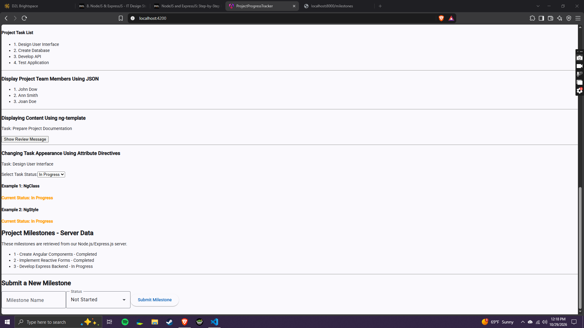
Screenshot of the GET request on ChromeDev Tools:
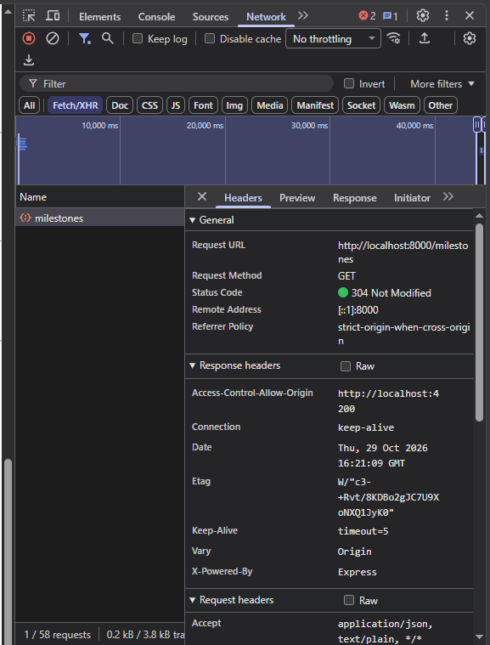
When the submit button is clicked, the Angular form will start the milestone service component. The milestone service will create a HTTP GET request that the async pipe will initiate. Express will receive the GET request and return the JSON records. Finally, angular will display the results of the GET request.

Part B: HTTP POST – Submitting Milestones
Screenshot of the Angular form successful submittal message:
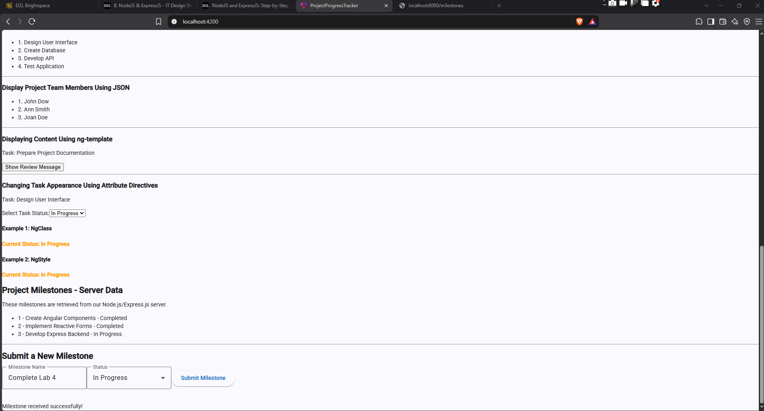
Screenshot of the POST ChromeDev Tool:
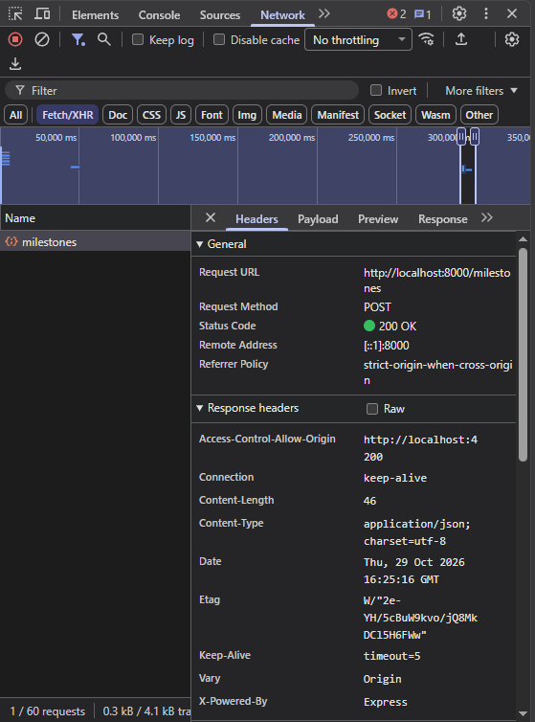
Screenshot of the Express Terminal:
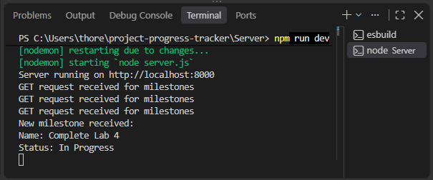
The Angular form will collect the values, then the service component will prepare and send a POST request. Express will receive the JSON information and will return a confirmation response that Angular will display.

